Encoding - decoding

# Packet

* 4 dices stores *offset* which is the position of the first character in the packet.
* 3 dices stores *length* of data stored in the packets, that is the number of symbols encoded in the packet.
* 1 dices stores *mode* of the packet
  + 0 for NORMAL: use 2 dices to encode a symbol
  + 1 for BASE86_TO_BASE10: Base86 – base10
  + 2 for Compress String – Bytes – Base10
  + 3 for Huffman – base10
  + 4 for smaz – base10
  + 5 for Smaz-huffman
* Other dices is for data

# Dice

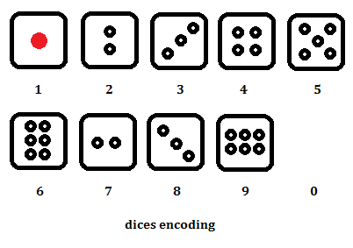

# How to send a message (assignment)

A message (assignment) is divided into packets with different lengths and different modes depends on characteristic of each sub message (length, meaning, symbol frequency). Sender will decide how message is divided and packet is send from one to one.

# How to send a packet

A packet hold 2 main things: offset and sub message. One important thing is mode, which is the method to encrypt and decrypt message to bytes (and then to dices).

A packet then is divided into pieces and each piece is send to receiver through a photo. A piece is a sequence of dices which are arranged to table of dices: 20 columns and 5 rows for maximum sizes. Dices are arranged in an A4 paper in horizontal direction.

* At the upper-left corner of the paper, there are n dices to show that it is the n-th packet *(n starts from 1)*.
* At the upper-right corner of the paper, there are m dices to show that it is the m-th piece of the packet *(m starts from 1)*.
* At the upper-center of the paper, there is a dice to show that it is the last piece of current packet. If there is no dice, it means that is not the last piece of current packet.
* A special dices (inclined) is place at the end of sequence of dices to indicate the piece is end (this help receiver know if there is 0-dice in the end of sequence of dices.)